ELECTRONICS
ECE 3455
LECTURE NOTES - DAVE SHATTUCK
SET #7
BIPOLAR JUNCTION TRANSISTOR AMPLIFIERS AND SWITCHES

Small Signal Equivalent Circuits for Amplifiers
When we say the transistor has been biased, it means that when we solve the dc problem (with signals set to zero) the transistor is in a desired region.
When the transistor is biased into the active, or linear, region, we can then solve the circuit again for the signal behavior. During this part, we set the dc sources to zero. We replace the transistor with an equivalent circuit, and then solve.

What equivalent circuit do we use? We will use a three parameter equivalent circuit. Let’s try to see where this model comes from, but looking first at the output characteristic of the transistor.
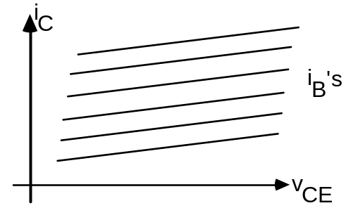
As we have said earlier, if these lines were horizontal, and equally spaced, then this would be modelled with a dependent source. The model in this case would be:
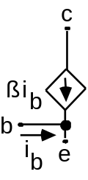

However, these lines have a nonzero slope.
This slope reflects a linear increase in i_{C} with increase in vCE. What would model a linear relationship between voltage and current?
The resulting model is:
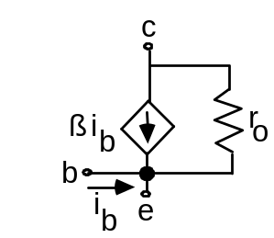
The value of ro is the inverse of the slope of the lines in the characteristic curves. Note that we use lowercase variables here, with lowercase subscripts, to indicate that it is a signal model.
This model works pretty well. But, we can make it more accurate still, by examining another characteristic curve. We plot iB as a function of vBE, which is called the input characteristic. We get something that looks like the following, essentially independent of other parameters:
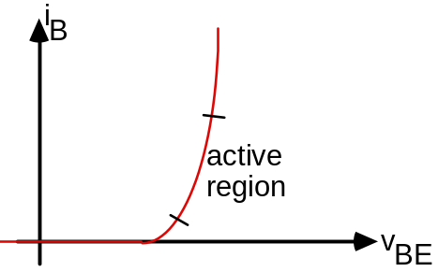

Here again, we can model the relationship in the active region with a straight line. What can we model this behavior with? Ans: With a resistor, of course.
More detailed answer: It is a resistor connected between base and emitter, such that the base current will be proportional to the voltage base to emitter.
Accordingly, our standard transistor model for this course will be as follows:
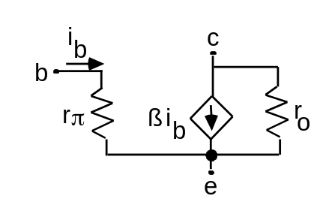

The value of rπ is the inverse of the slope of the line in the input characteristic, evaluated at the dc bias point.
Now this model will be very handy, and can be used for npn and pnp BJT’s.
Note: it is valid only for signals, and the values are a function of where we are biased.
Notice that it is just like the equivalent circuit for a current amplifier that we saw at the beginning of the course. Remember that we can convert this to a voltage amplifier, transconductance amplifier, or transresistance amplifier.
Sometimes the resistor ro can be neglected. In this case, we get the very common version that follows.
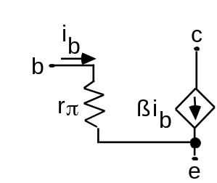

We can get a good approximation for rπ by using the following relationship.

rπ = VT / IB

We note that VT, the thermal voltage, is approximately equal to 25[mV] at room temperature. Note also that IB is the dc value of the base current.
We can get a good approximation for ro by using the following relationship.

ro = VA / IC

The VA, the Early voltage, is another parameter we must be given. It is typically in the range of 50-100[V]. Note also that IC is the dc value of the collector current.
With this, we can get a pretty good model for the transistor, and only need to know ß to be able to get it. For any problem where you are not given values of ro or VA or rπ, you may assume
a) room temperature operation, which allows you to solve for rπ after you get the dc bias conditions, and
b) ro = ∞ .

Solve some sample circuits. Try: RC = 1[kΩ],
RB1 = RB2 = 1[MΩ], ß = 200, RE = 0, RL = 1[kΩ], VCC = 12[V] and VEE = -12[V]. Apply input at base, take output at the collector. Find the signal voltage gain. Separate source and load from the amplifier with large capacitors.
a) Find the voltage gain.
b) Find the current gain.
c) Find the input resistance.
d) Find the output resistance.
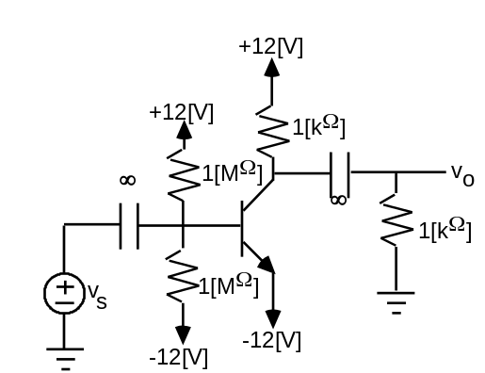

Solution: The first step is to find the dc bias conditions. The capacitors block dc, so the load and the source can be ignored.
If we take the Thevenin equivalent at the base, we get a zero valued source and a 500[kΩ] Thevenin resistance. Redraw and we get:
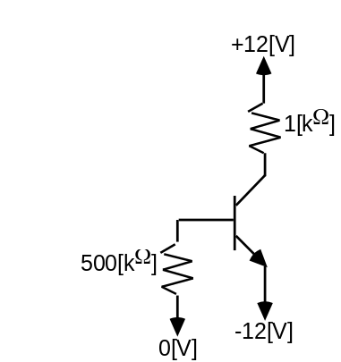
Assume Linear Region.
We get VE = -12[V], and
VB = -11.3[V] due to VBE = 0.7[V].
Then, IB = {0 - (-11.3) [V]} / 500[kΩ] = 23[µA]
and from IC = ß IB we get IC = 4.6[mA] = IE.
Using IC, we get VC = 12[V] - (4.6[mA])(1[kΩ])
or VC = 7.4[V].
test: bc jct rev. biased, check
all currents positive, check. Good assumption.
So, now we plug in the ac small signal equivalent circuit. The resistor value
rπ = VT / IB = 25[mV] / 23[µA] = 1.1[kΩ].
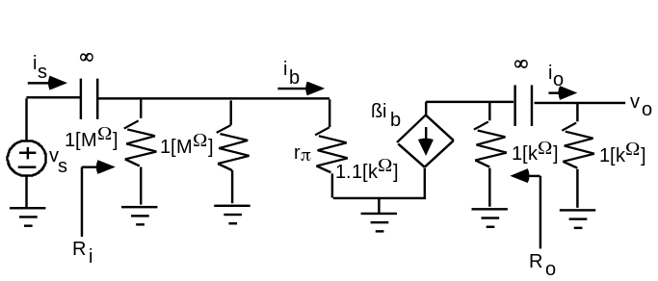
Now, we are going to treat the capacitors as short circuits for the signal part of this problem. Let's solve:
ib = vs / 1.1[kΩ]
vo = -ß ib (1[kΩ] || 1[kΩ])
So, Av = vo / vs = -200 (500/1100) = -91
and
Ai = io / is = {vo / 1000[Ω]} / {vs / 1.1[kΩ]} = Av (1.1)
Ai = -100.
We can use our typical approximation approach to find that
Ri = 1.1[kΩ]. In general, we use a test source to get this value.
To get Ro, we remember that we set independent sources (vs) equal to zero.
Thus, ib = 0, and Ro = 1[kΩ]. In general, we use a test source to get this value.

There are three commonly used transistor amplifier configurations.
Common Emitter Amplifier - Input at base, output at collector, voltage gain (inverts), current gain.
Common Collector Amplifier - Input at base, output at emitter, current gain, voltage gain equal to one (aka the Emitter Follower).
Common Base Amplifier - Input at emitter, output at collector, voltage gain, current gain equal to one.

Each configuration has special applications.

End of 19th lecture

Digital Circuits, How They Are Built and Evaluated

Objective: to understand the internal components of digital chips, so that we can use them wisely.

Digital signals have 2 allowable states. These are usually represented by 2 voltage levels. However, we have a variety of names for these two states:
High and Low
True and False
1 and 0

The Phoenician says:
Positive logic - 1 is higher voltage, 0 is lower voltage
Negative logic - 0 is higher voltage, 1 is lower voltage
We will use positive logic exclusively in this course.

Some simple logic gates and their truth tables follow. A truth table is a list of the relationship between inputs and outputs. Remember that there are only two possibilities for every input and output.

Logic Inverter:
A B 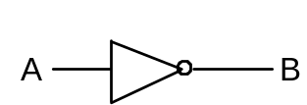
0 1
1 0

OR Gate:
A B C 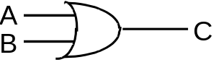
0 0 0
0 1 1
1 0 1
1 1 1

NOR Gate:
A B C 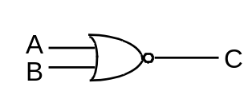
0 0 1
0 1 0
1 0 0
1 1 0

AND Gate:
A B C 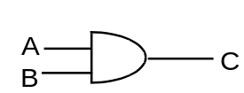
0 0 0
0 1 0
1 0 0
1 1 1

NAND Gate:
A B C 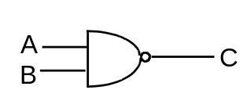
0 0 1
0 1 1
1 0 1
1 1 0

Evaluation of Digital Circuits
Section A.3 of the Hambley Text (in Appendix A)

The following characteristics provide the basis for comparison of different kinds of gates, called Logic Families. Logic Families are groups of similar circuits used to generate logic gates.

1. Noise margin
2. Fanout
3. Power dissipation
4. Propagation Delay

1. Noise Margin - resistance or immunity to noise.
To demonstrate what this means, look at the following transfer characteristic for an inverter.
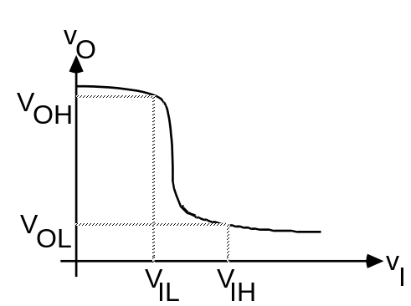

VOH = VOut High Min = the minimum voltage that is available at the output, when the output is "high". In other words, the "high" output voltage is at least this high.

VIH = VIn High Min = the minimum voltage that is unambiguously recognized as being a "high" voltage, at the input. In other words, any voltage that is at least this high, will act as a "high" voltage at the input.

VOL = VOut Low Max = the maximum voltage that is available at the output, when the output is "low". In other words, the "low" output voltage is at least this low.

VIL = VIn Low Max = the maximum voltage that is unambiguously recognized as being a "low" voltage, at the input. In other words, any voltage that is at least this low, will act as a "low" voltage at the input.

The values for VOH, VOL, VIH and VIL are determined in part by the transfer characteristic, and partly by the choices of the designer of the gate. Typically, VIH and VIL are chosen, and then VOH and VOL follow from that. See diagram.

With these definitions in mind, we can define noise margin in terms of these values. See the diagram, which is a plot on a single voltage axis of these four voltages.
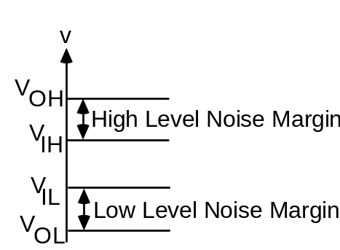

The High Level Noise Margin is the difference between VOH and VIH. In other words, the noise that the circuit can tolerate in the "high" state, is the difference between the minimum that it will get from the output of the previous gate, and the minimum voltage that it can tolerate at the input.

The Low Level Noise Margin is the difference between VIL and VOL. In other words, the noise that the circuit can tolerate in the "low" state, is the difference between the maximum voltage that it can tolerate at the input, and the maximum that it will get from the output of the previous gate.

2. Fanout - The fanout is defined as the number of gates that can be "driven" by the output of a gate, and still have everything operate "correctly". It is important to recognize that a single output can, and generally will, be connected to more than one input somewhere. The term "correctly" can be defined in many ways, typically in terms of minimum noise margin, and/or maximum propagation delay.

The fanout and noise margin are dependent on each other. This is because the fanout changes the transfer characteristic of a gate.
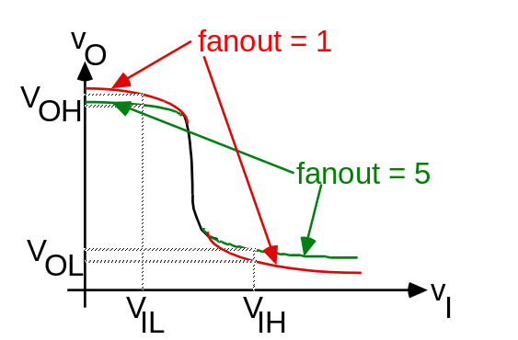

This change in transfer characteristic results in a change in noise margin.

Notice that the noise margin get smaller when the fanout gets larger. There is a tradeoff between the two.

3. Power Dissipation. The power dissipation is the amount of power that must be provided to a gate. There are two ways that this is considered.
a) dc Power - I V - in one state. In other words, how much power is consumed when the gate is not changing state.
b) Dynamic Power - power consumed in order to change state. Typically, this is due to the need to move charges stored at a junction when changing states.
The dynamic power can be the dominant part of the power dissipation, as is the case with CMOS. In this case, there is almost no power dissipated except when changing state.

4. Propagation Delay - The propagation delay is the time required for the output of the gate to reach 90% of the final value.
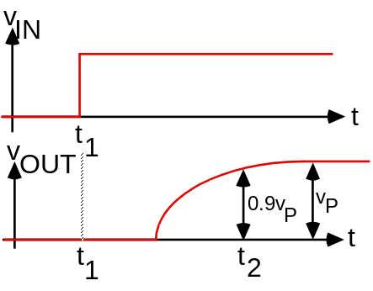
So, the propagation delay is t2 - t1.
This propagation delay is due to capacitances, inductances, finite distances, and that kind of thing.
Typically, there is a direct tradeoff between propagation delay and power dissipation. This is often expressed as a Power-Delay Product. The concept is that the product of these two quantities is often a constant. However, it is important that this is not overdone, since for changes in approaches, this "constant" can vary.

Resistor-Transistor Logic - RTL - obsolete but simple and illustrative logic family. Like looking for the key on Main Street.

Let’s look at a sample RTL circuit and analyze it.

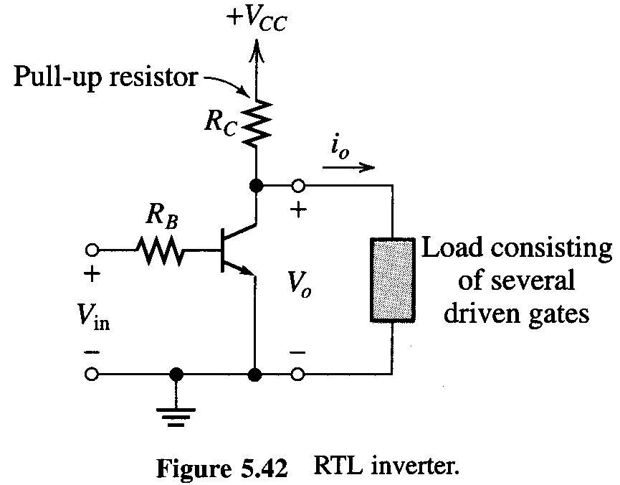

It is usually assumed that we will use the output of our gates to drive the inputs of other gates. Therefore, our general procedure will be to take outputs that look like the outputs above, and connect them to inputs like the input above.

We will use the following parameters:
VBESAT = 0.7[V] VCESAT = 0.2[V]
ßFmin = 40
VCC = 5[V] RB = 5[kΩ]
RC = 2[kΩ]

Now, just as a place to start, we will assume that the high state is a voltage equal to VCC, in this case, 5[V]. Similarly, we will assume that the low state is 0.

Why is this reasonable? Ans: These are the extremes of the power supply values we have. Thus, if these don’t work, nothing will. They will work, and we will replace them with better estimates later.

Now, let us start somewhere. Let us assume that the input is low. It can be shown (using dc transistor analysis) that the transistor will turn off. If the transistor is in cutoff, the output must be equal to VCC, or 5[V].

Next, we take the case where the input is high, which we are assuming for now is 5[V]. Again, dc analysis will show that the transistor is in saturation. With the transistor in saturation, we will have an output voltage equal to
VCESAT = 0.2[V].

We now know certain things.
Examining the truth table, we find that we have a gate that provides a logical inversion, an inverter.
The high state output is equal to VCC. Thus, we know that
VOH = 5[V].
The low state output is equal to VCESAT. Thus, we know that
VOL = 0.2[V].
Actually, these values are only valid for no gates connected to the output. We can think of these as values for fanout = 0. We will use the notation:
VOH0 = 5[V]
and
VOL0 = 0.2[V].

Next, let us look at fanout. Let’s start with the low state fanout (that is, the fanout when the output is in the low state). The key relationship for the low state is the one for saturation of the transistor, namely
IC / IB < ßFmin = 40
In this example,
IB = (5 - 0.7) [V] / 5[kΩ] = 860[µA].
IC = {{5 - (0.2) [V]} / 2[kΩ]} + n IInLow
= {2400[µA]} + n IInLow,
where

n = the number of gates driven, and
IInLow = the current coming out of the input of each gate driven. We can get this value by looking at the situation where an input is low.
For these gates, we have the unusual case where there is very little current coming out of the gate in the case where the input is low. That’s because when the input (of the driven gate) is low, the transistor (of the driven gate) is off. So, here,
IInLow = 0,
and
IC / IB = {2400 + n0}/860 < 40,
which is always true, for any n. Thus, the fanout in the low output state is extremely large. We will call it infinite. In general, we would solve the inequality,
IC / IB = {2400 + n IInLow }/860 < 40,
for n, and get the fanout for the low state.

What about the high state? For the high state output, we have a transistor (for the driving gate) which is in cutoff. This then is effectively a Thevenin’s equivalent with
VTH = 5[V],
and
RTH = 2[kΩ].
Now, this output needs to drive the transistors for all of the driven gates into saturation. For saturation,
IC / IB < ßFmin = 40
The value for IC is known to be 2.4 [mA], and IB can be solved to find
IB = {(5 - 0.7)[V] / (2 + 5/n)[kΩ]}/n
Where, again, n is the fanout.
We now have an inequality that we can solve, obtaining
n < 33.3.
It is meaningless to have a noninteger fanout. The fanout is the next lowest integer, so the high state output fanout is 33.

Now, there is really only one fanout. That is the lower value of the two. Specifically, the answer to the question, what is the fanout, is

fanout = 33.

While we solve for “high state fanout” and “low state fanout” during our analysis process, they don’t have any meaning outside the analysis process.

Noise Margin Calculation:
Now, we have assumed that the noise margin was not a factor in these fanout calculations. In the typical case, this is not true. Let’s find the noise margins.
Now, we need VIH and VIL.

Let’s look the the low state case. When the output is low, the following gates should have the transistor in cutoff. The question we need to ask is, as the output goes higher and higher, when will this assumption begin to be untrue?
Ans. When the input reaches 0.7[V], the transistors in the driven gates will begin to turn on. This, then, is a reasonable estimate for VIL.
We already know that VOL = 0.2[V], since this corresponds to a saturated transistor output
Thus, the noise margin in the low state is:
nmL = VIL - VOL = 0.7 - 0.2 = 0.5[V].
(note: Generally speaking, VOL is a function of fanout. In this case, for our model of saturation, the output voltage does not change with fanout. This is a special case. In general, we will have a noise margin which changes with fanout.)

Now, we look at the high state case:
When the output is high, the following gates should have the transistor in saturation. The question we need to ask is, as the output goes lower and lower, when will this assumption begin to be untrue?
We have already said that for saturation, we must have
IC / IB < ßFmin = 40
Since IC is known to be 2.4[mA], IB must be greater than 60[µA] for each gate. Thus, the input voltage must be at least
VIH = 0.7[V] + 60[µA]5[kΩ] = 1.0[V]
Now, we need VOH. This is harder, since this is a function of the fanout. Let’s take the fanout to be 10. Then, we can show that
VOH10 = 5[V] - {(5-0.7)[V]/(2+5/n)[kΩ]}(2[kΩ]) = 1.6[V]
Then,
nmH = VOH - VIH = 1.6 - 1.0 = 0.6[V].
Strictly speaking, we have found the high state noise margin, for a fanout of 10, to be
nmH = 0.6[V].

Next, let’s look at some sample problems. These problems use the concepts that we have used here, but in different ways. The key concepts are:
- the definitions of noise margin and fanout
- a high-state output is connected to n high-state inputs, and
- that a low-state output is connected to n low-state inputs.
Let’s use these concepts to solve these sample problems.

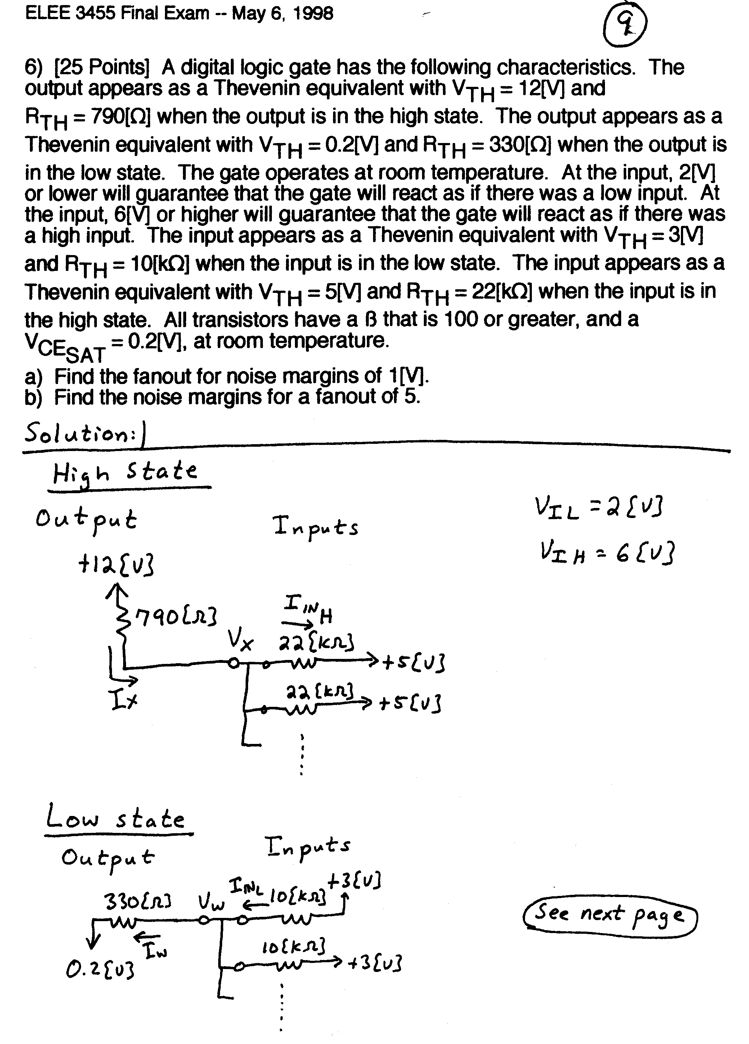
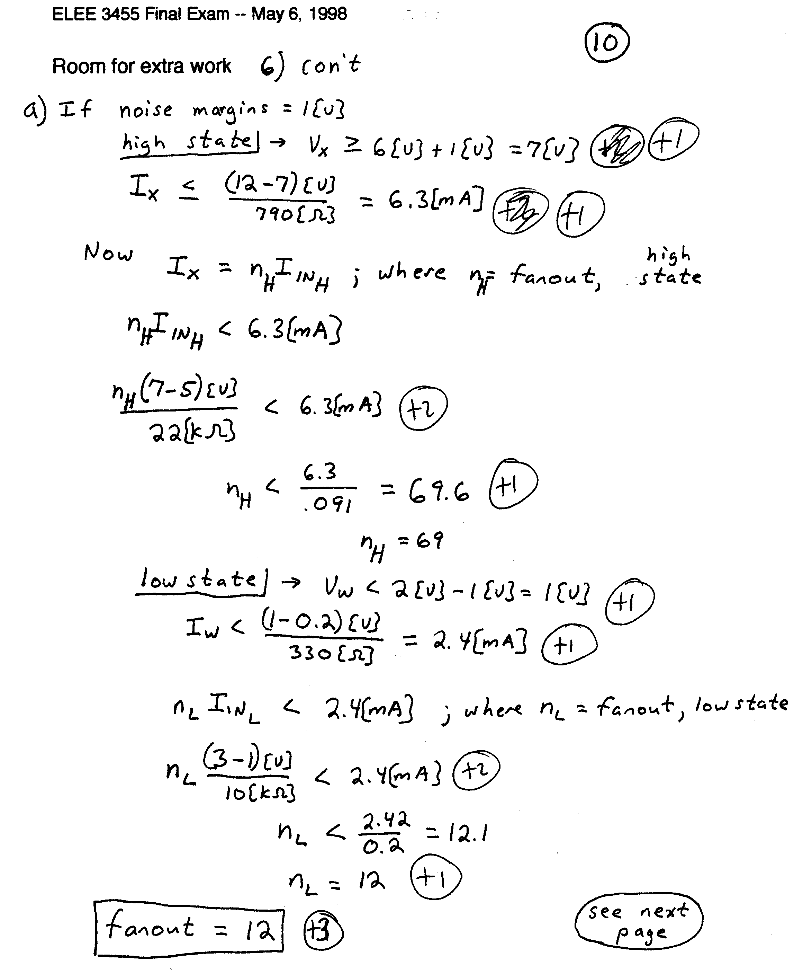

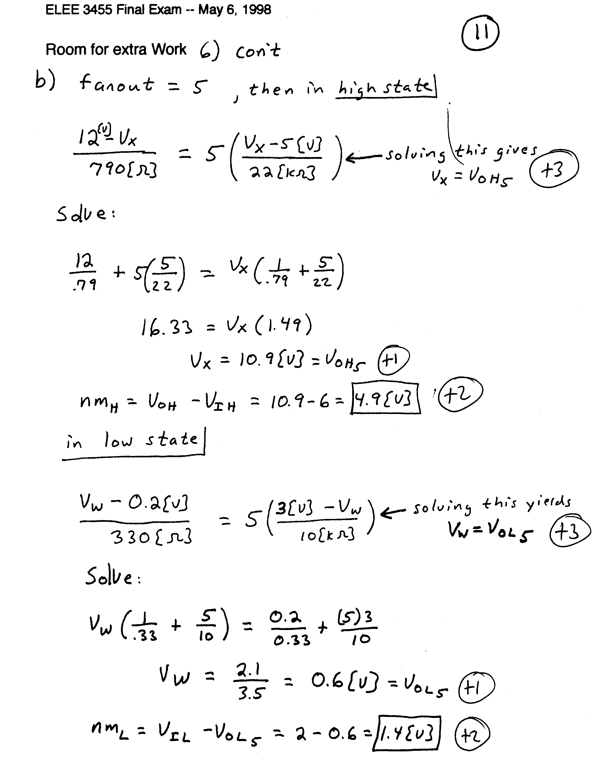

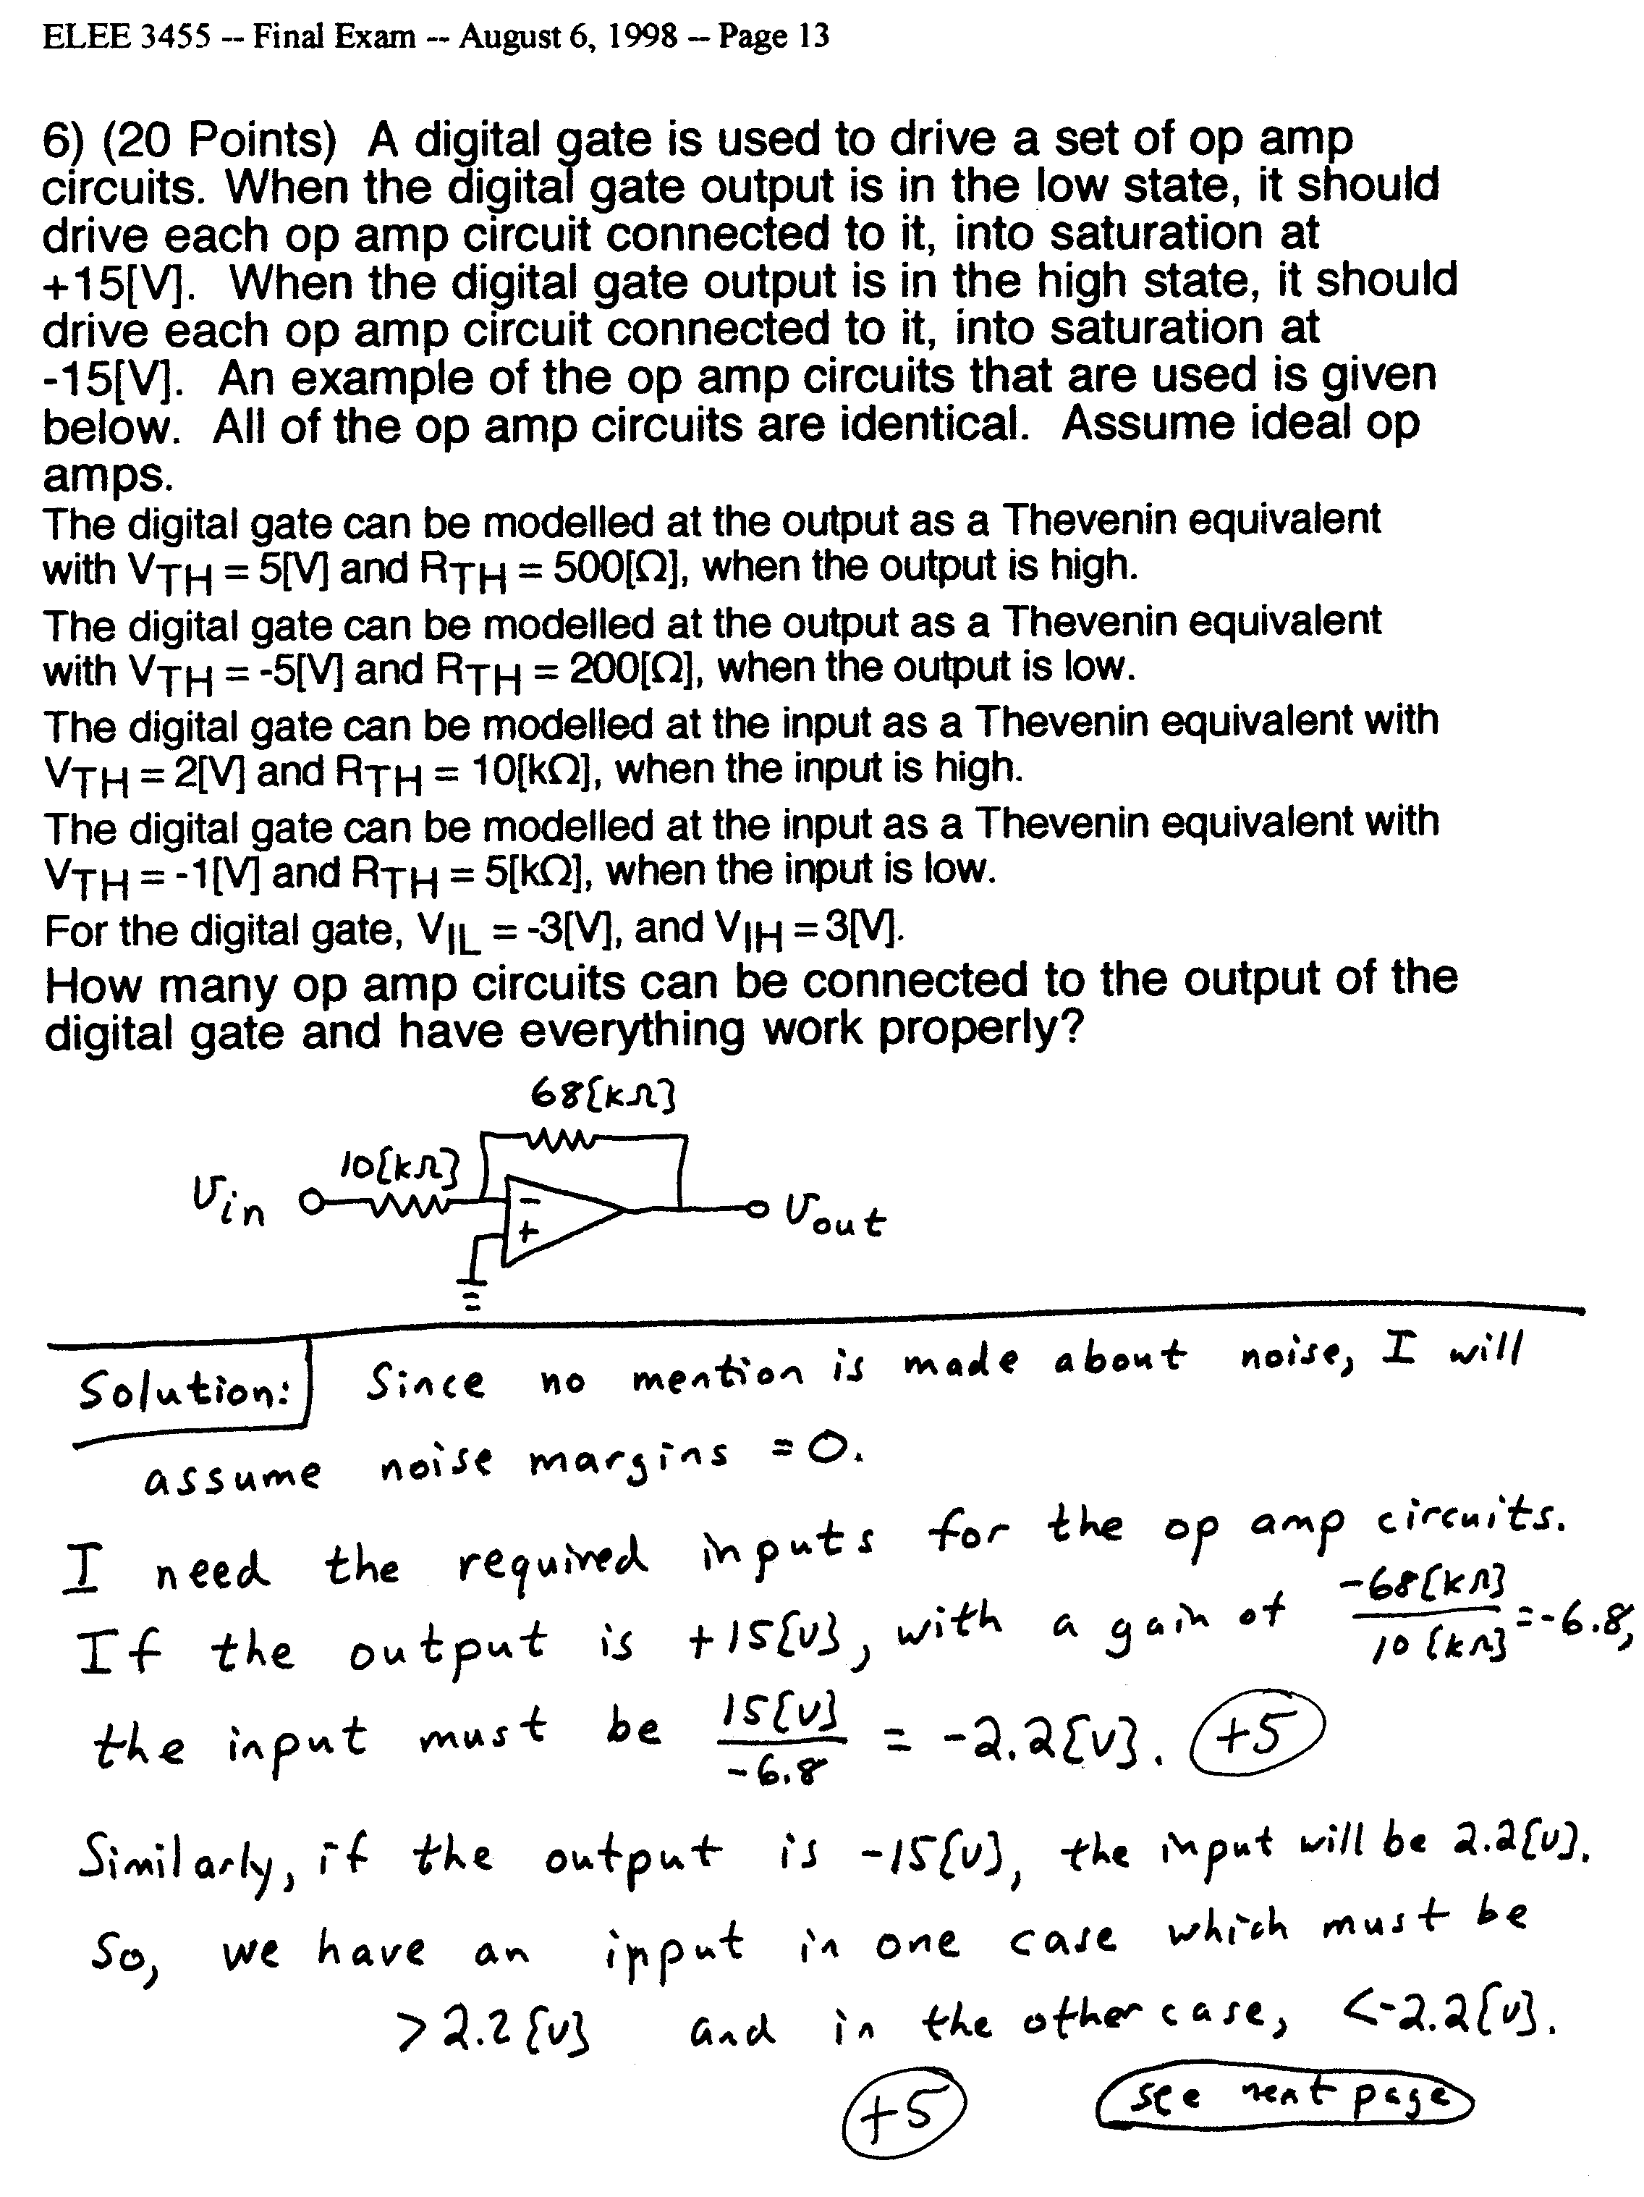
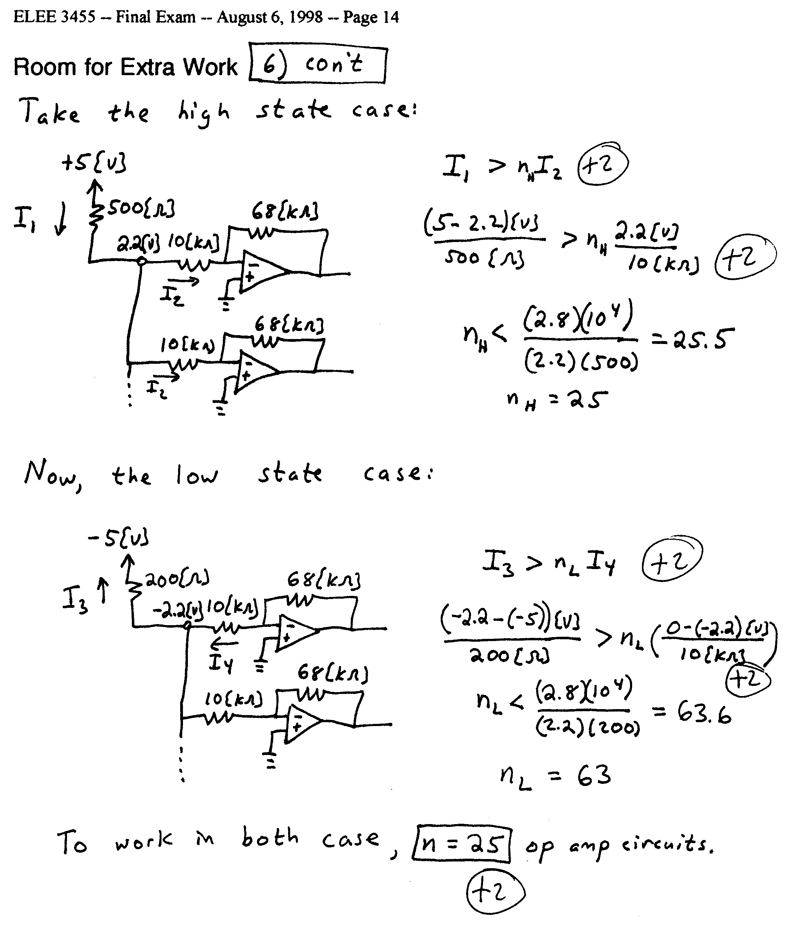
A digital logic family has the characteristics described below.
a) The output appears as the equivalent circuit in Fig. 7 when the output is in the high state. The output appears the equivalent circuit in Fig. 8 when the output is in the low state.
b) The input appears as the equivalent circuit in Fig. 9 when the input is in the high state. The input appears the equivalent circuit in Fig. 10 when the input is in the low state.
c) The gate dissipates 250[mW] when the output is in the high state, and dissipates 240[mW] when the output is in the low state.
d) Assume room temperature operation, β = 100, and V_{A} = ∞.
e) The lowest input voltage that behaves like a high input is 2[V]. The highest input voltage that behaves like a low input is -2[V].

Find the fanout for high and low noise margins of 1[V].

